The Central Processing Unit (CPU)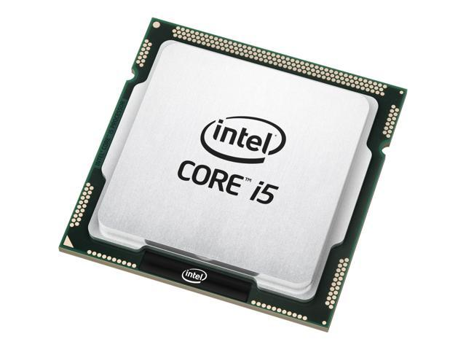



Crash Course Computer Science #7  
**The Central Processing Unit**

<https://www.youtube.com/watch?v=FZGugFqdr60>

Software programs are sets of instructions. For a CPU to execute these instructions, each one must first be translated into **machine code** – simple binary codes that activate parts of the CPU.

The CPU only performs a few basic functions:

* performing mathematical operations like addition and subtraction
* moving data from one memory location to another
* making decisions and jumps to a new set of instructions based on those decisions

A piece of software, such as a game or web browser, combines these functions to perform more complex tasks.

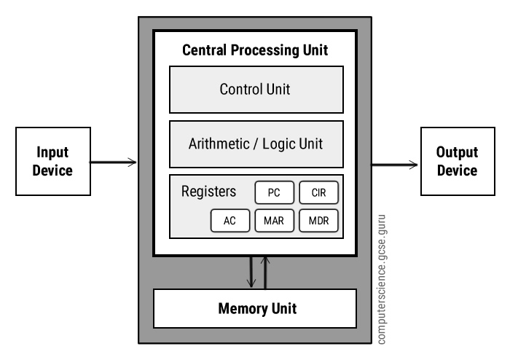

**Internals**

* Arithmetic Logic Unit
* Control Unit
* Registers   
  (or ‘Immediate access memory stores’)
* Cache Memory

(or ‘Memory Unit’)

**Arithmetic Logic Unit**

An arithmetic logic unit (ALU) is a **digital circuit used to perform arithmetic (maths) and logic (if, elif, else) operations**. It represents the fundamental building block of the central processing unit (CPU) of a computer. Modern CPUs contain very powerful and complex ALUs. In addition to ALUs, modern CPUs contain a control unit (CU).

Most of the operations of a CPU are performed by one or more ALUs, which **load data from input registers**. A register is a small amount of storage available as part of a CPU. The control unit tells the ALU what operation to perform on that data and the ALU stores the result in an output register. The control unit moves the data between these registers, the ALU, and memory.

**Control Unit**

A control unit **coordinates how data moves around a cpu**. The control unit (CU) is a component of a computer's central processing unit (CPU) that directs operation of the processor. **It tells the computer's memory, arithmetic/logic unit and input and output devices how to respond to a program's instructions.**

* **The control unit obtains data / instructions from memory**
* **Interprets / decodes the instructions into commands / signals**
* **Controls transfer of instructions and data in the CPU**
* **Coordinates the parts of the CPU**

**Registers  
NOTE** : Some of the smaller details like the individual register names may not be examinable but I’d be familiar with the Program Counter register and it’s job.

In computer architecture, **a processor register is a quickly accessible location available to a digital processor's central processing unit** (CPU). Registers usually consist of a **small amount of fast storage.** Collectively they are sometimes referred to as the **immediate access store.**

Almost all computers load data from a larger memory into registers where it is used for arithmetic operations and is manipulated or tested by machine instructions. Manipulated data is then often stored back to main memory. Processor registers are normally at the top of the memory hierarchy, and provide the **fastest way to access data**. The term normally refers only to the group of registers that are directly encoded as part of an instruction, as defined by the instruction set.

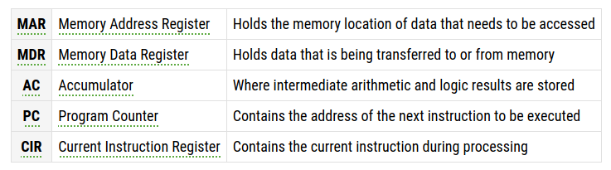

**Cache Memory**

Cache memory is a chip-based computer component that makes **retrieving data from the computer's memory more efficient**. It acts as a **temporary storage area that the computer's processor can retrieve data from easily**. This temporary storage area, known as a cache, is more readily available to the processor than the computer's main memory source, RAM.

Cache memory is sometimes called CPU (central processing unit) memory because it is typically integrated directly into the CPU chip or placed on a separate chip that has a separate bus* interconnect with the CPU. Therefore, it is more accessible to the processor, and able to increase efficiency, because it's physically close to the processor.

In order to be close to the processor, cache memory needs to be much smaller than main memory. Consequently, it has less storage space. It is also more expensive than main memory, as it is a more complex chip that yields higher performance.

**What it sacrifices in size and price, it makes up for in speed. Cache memory operates between 10 to 100 times faster than RAM**, requiring only a few nanoseconds to respond to a CPU request.

**\***In computer architecture, a bus is a communication system that transfers data between components inside a computer, or between computers. This expression covers all related hardware components (wire, optical fiber, etc.) and software.

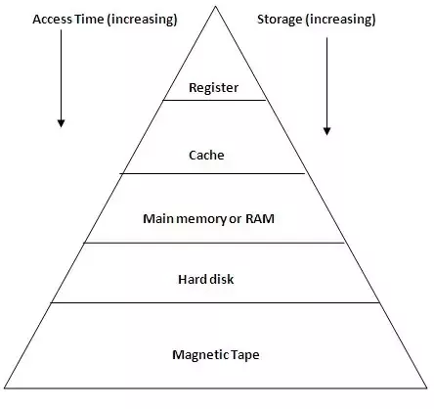

**\*\*\* This section below is important \*\*\***

**Fetch-Execute Cycle**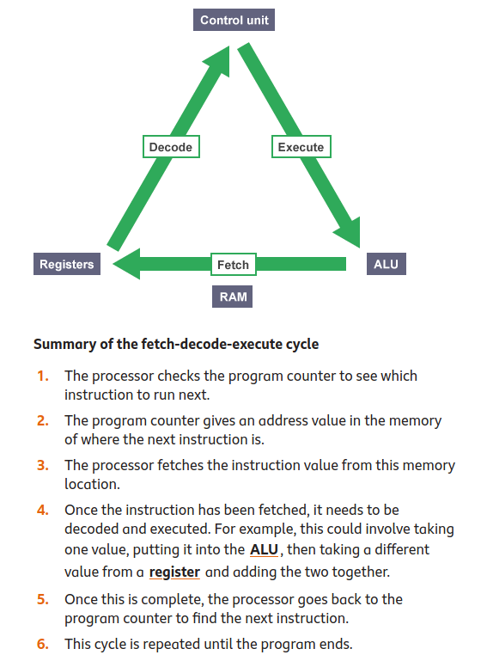

The main job of the CPU is to execute programs using the fetch-decode-execute cycle (also known as the *instruction cycle* or *fetch-execute cycle*). This cycle begins as soon as you turn on a computer.

To execute a program, **the program code is copied from secondary storage (e.g. harddrive) into the main memory. The CPU's program counter is set to the memory location where the first instruction in the program has been stored, and execution begins. The program is now running.**

In a program, each machine code instruction takes up a slot in the main memory. These slots (or memory locations) each have a unique memory address. **The program counter stores the address of each instruction and tells the CPU in what order they should be carried out.**

When a program is being executed, the CPU performs the fetch-decode-execute cycle, which repeats over and over again until reaching the STOP instruction.

**Instructions**

Modern day programmers write their programs (series of instructions) in a **high-level programming language** such as Java, C++ or Python. These instructions need to be translated to binary code before the CPU can process them. High-level languages are easier to read and write than binary digits so are good for humans - we say they are ‘**human readable**’ as opposed to binary which is ‘**machine readable**’. There are **low-level languages** such as Assembly which are closer to machine readable than to human readable - the advantage of these languages is that they are quicker for computers to convert to machine code than higher level languages.

A piece of software called a **Translator** converts high-level languages to machine code, there are different types of Translator.

* **Compiler** : translates human-readable program directly into executable, machine readable form before the program runs. C and C++ are compiled languages.
* **Interpreter** : translates instruction by instruction, waiting until one completes before moving to the next one. Python is an interpreted language.

**Benchmarking**

A test used to **assess the performance of a computer**. Different types of benchmark software are used for the **different kinds of application** you might want a computer to do.

It is difficult to assess the performance of a CPU because a computer might excel at some tasks but not do so well at others. For example, a computer that is going to be used for gaming will require the best combination of hardware to handle intensive graphics quickly. The same computer might not perform so well if it was used to analyse vast amounts of scientific data.

## **Cores**

A CPU can contain one or more processing units. Each unit is called a **core**. **A core contains an ALU, control unit and registers**. It is common for computers to have two (dual), four (quad) or even more cores. CPUs with multiple cores have more power to run multiple programs at the same time. **However, doubling the number of cores will not simply double a computer's speed.** CPU cores have to communicate with each other through channels and this uses up some of the extra speed.

## **Clock speed**

The **clock speed** - also known as clock rate - indicates how fast the CPU can run. This is measured in **megahertz (MHz) or gigahertz (gHz)** and **corresponds with how many instruction cycles the CPU can deal with in a second.** A 2 gHz CPU performs two billion cycles a second. A faster CPU uses more energy and creates more heat.

A computer will normally have a maximum clock speed set by default, but it is possible to change this speed in the computer BIOS. Some people increase a CPU clock speed to try to make their computer run faster - this is called **overclocking**.

**Read More & Test Yourself**

CPU and Memory <https://www.bbc.co.uk/bitesize/guides/zmb9mp3/revision/1>

CPU and Fetch-Execute Cycle <https://www.bbc.co.uk/bitesize/guides/zws8d2p/revision/1>

Fetch-Execute Cycle <https://www.bbc.co.uk/bitesize/guides/z2342hv/revision/5>

Fetch-Execute Cycle <https://www.computerscience.gcse.guru/theory/fetch-execute-cycle>